ANNEX II + III: TECHNICAL SPECIFICATIONS + TECHNICAL OFFER

Contract title: Framework Contract for the Supply of Visibility items p 1 /…
Publication reference: EUMM-26-10289

Columns 1-2 should be completed by the Contracting Authority
Columns 3-4 should be completed by the tenderer
Column 5 is reserved for the evaluation committee
Annex III - the Contractor's technical offer
The tenderers are requested to complete the template on the next pages:
- Column 2 is completed by the Contracting Authority shows the required specifications (not to be modified by the tenderer),
- Column 3 is to be filled in by the tenderer and must detail what is offered (for example the words “compliant” or “yes” are not sufficient)
- Column 4 allows the tenderer to make comments on its proposed supply and to make eventual references to the documentation
The eventual documentation supplied should clearly indicate (highlight, mark) the items offered and the options included, if any, so that the evaluators can see the exact configuration. Offers that do not permit to identify precisely the items and the specifications may be rejected by the evaluation committee.
The offer must be clear enough to allow the evaluators to make an easy comparison between the requested specifications and the offered specifications.
For all products must be indicated the exact product offered and provided sample photos, link to manufacturer site or any other proof of the product’s characteristics.
The Contractor’s offer must include the cost for design and layout. The design of each visibility item (incorporating the visual identity of the Contracting Authority) must be provided by the Contractor after this has been discussed and agreed with the Contracting Authority. Logos and photos will be provided by Contracting Authority. The Contracting Authority must approve final designs before ordering.
The Contractor might be asked to provide several designs and be tasked to change/revise design according to Contracting Authority’s preference.
The packaging shall become the property of the recipient subject to environmental considerations.
The place of acceptance of the supplies shall be EUMM warehouse at 15 Nestan-Darejani Street (Didi Dighomi), Tbilisi, Georgia DDP or at other addresses in Tbilisi, Georgia, which will be specified in the Order Forms. The delivery shall take place within 45 (forty-five) calendar days after signature of the order form by both parties.
All the products will have a warranty of 12 months.
NOTE: It is the responsibility of the tenderer to cover all shipment costs in the event of warranty issues.
All the quantities are only estimate.
In addition to the key items listed above, the Contracting Authority may also procure a wide range of other visibility items from the Contractor's catalogue, as required throughout the duration of the contract.
1.  Item Number | 2.  Specifications Required | 3.  Specifications Offered | 4.  Notes, remarks,  ref to documentation | 5.  Evaluation Committee’s notes
1 | Ballpoint Pen QTY: 10,000  • Outer material: Plastic  • Top or twist operated  • Ergonomic design  • Metal ballpoint  • Writing colour: Blue  • Outer colour: EU blue (Pantone Reflex Blue) or similar blue colour  • Printing on the max. available area of the body of the pen (one side) in two colours: Pantone Yellow and Pantone White  • Design: Will be developed by the Contractor in conjunction with the Contracting Authority  Illustration for guidance only:  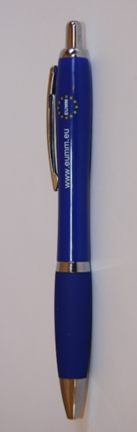
2 | Thermos Bottle QTY: 1000  • Vacuum Insulated  • Twist-on lid or similar tight locking lid  • No handle  • Single-hand operated opening for drinking  • Content: 500 ml – 750ml  • Outer colour: EU blue (Pantone Reflex Blue) or similar blue colour  • Printing of EUMM logo on one side in two colours: Pantone Yellow and Pantone White (Logo diameter: 55-60 mm)  • Design: Will be developed by the Contractor in conjunction with the Contracting Authority.  Illustration for guidance only:  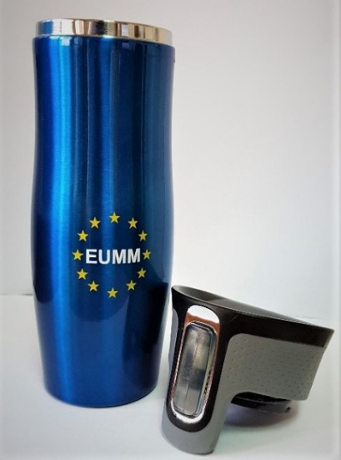  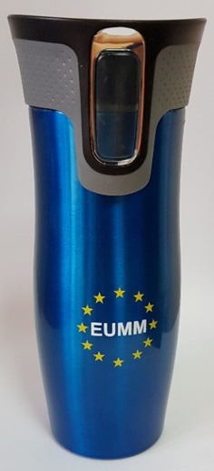
3 | Ceramic Coffee Mug : QTY: 1000  • Outer material: Ceramic  • Outer and inner colour: EU blue (Pantone Reflex Blue) or similar blue colour  • Content: 300-350 ml  • Printing of EUMM logo on both sides in two colours: Pantone Yellow and Pantone White (Logo diameter: 55-60 mm)  • Design: Will be developed by the Contractor in conjunction with the Contracting Authority.  Illustration for guidance only:  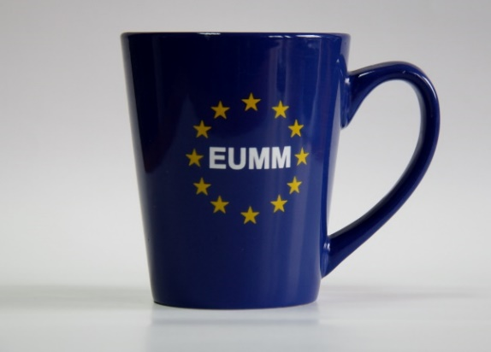  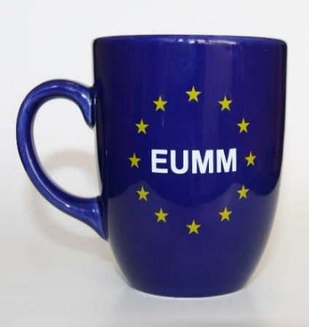
4 | Shopping bag QTY: 2500  • Size 350 mm (W) x 400 (H) mm, ± 100 mm  • Outer material: Canvass (woven material) or non-woven  • Colour: EU blue (Pantone Reflex Blue) or similar blue colour  • Printing of EUMM logo on both sides in two colours: Pantone Yellow and Pantone White (logo diameter: 150-250 mm)  • Design: Will be developed by the Contractor in conjunction with the Contracting Authority.  Illustration for guidance only:  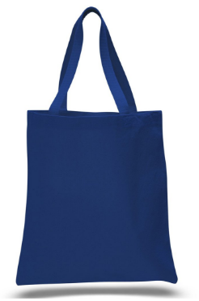  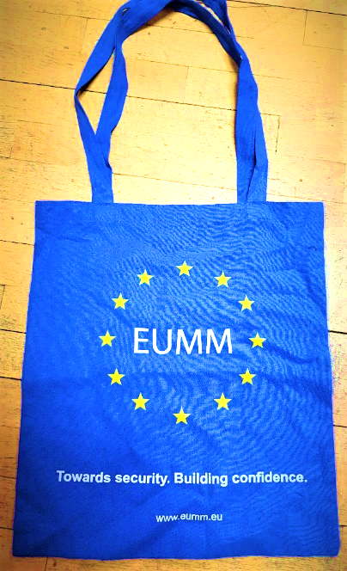
5 | Monitor Teddy Bear QTY: 1000  • Stuffed Teddy Bear  • Dressed in EU-blue (Reflex Blue or similar blue) T-shirt or monitor gilet look alike.  • Overall size min. 125 mm, max. 200 mm, ± 10 mm  • Printing on shirt/gilet in two colours: Pantone Yellow and Pantone White  • Design: Will be developed by the Contractor in conjunction with the Contracting Authority  • Packing: Bulk in boxes of max 50 units.  Illustration for guidance only :  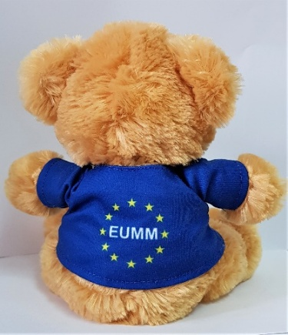  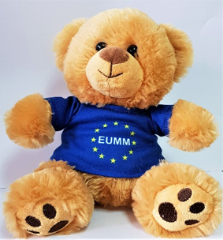
6 | Notebooks A5 : QTY : 3000  Format  • Size A5: Size (148 mm (W) x 210 mm (H)  Pages and binding  • Pages: 50 sheets (100 pages)  • Wrapped cover with glue-binded pages  Cover design  • Layout and Design: Will be developed by the Contractor in conjunction with the Contracting Authority.  Illustration for guidance only:  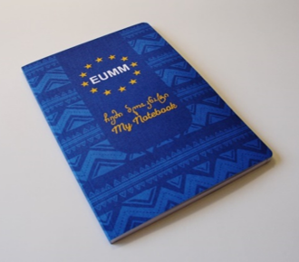
7 | Notebooks A6 : QTY : 3000  Format  • Size A6: Size (105 mm (W) x 148 mm (H)  Pages and binding  • Pages: 50 sheets (100 pages)  • Wrapped cover with glue-binded pages  Cover design  • Layout and Design: Will be developed by the Contractor in conjunction with the Contracting Authority.  Illustration for guidance only:
Re-usable Water Bottle: QTY: : 1000

• Insulated material
• Content: 750ml-1000ml
• Outer colour: EU blue (Pantone Reflex Blue) or similar blue colour
• Printing of EUMM logo on one side in two colours: Pantone Yellow and Pantone White (Logo diameter: 55-60 mm)
• Design: Will be developed by the Contractor in conjunction with the Contracting Authority.

Illustration for guidance only:

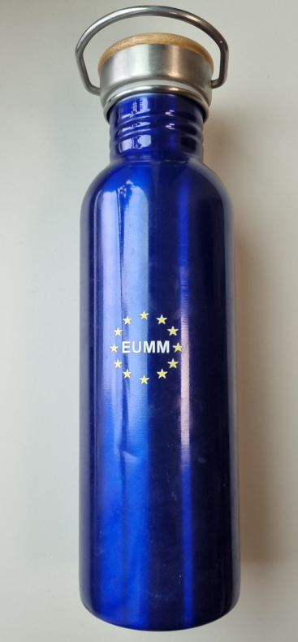

Name and first name: <…………………………………………………………………>
Duly authorised to sign this tender on behalf of:
<……………………………………………………………………………………>
Place and date: <…………………………………………………………….………….>
Stamp of the firm/company:

